***Jesus & Modern Morality***

**Dr. David Bray - January 31, 2021**

**Scripture Text: *Matthew 5:17-19****“Do not think that I came to destroy the Law or the Prophets. I did not come to destroy but to fulfill. 18 For assuredly, I say to you, till heaven and earth pass away, one jot or one tittle will by no means pass from the law till all is fulfilled. 19 Whoever therefore breaks one of the least of these commandments, and teaches men so, shall be called least in the kingdom of heaven; but whoever does and teaches them, he shall be called great in the kingdom of heaven.”* **Jesus confirms the Law’s:**

**1**

**Ultimate ____________-***“Do not think that I came to destroy the Law or the Prophets. I did not come to destroy but to fulfill.” (vs. 17)*

**2**

_______________**-** *“For assuredly, I say to you, till heaven and earth pass away, one jot or one tittle will by no means pass from the law till all is fulfilled.” (vs. 18)* **Jesus fulfilled the:**

* 1. _____________ **law and assumed the new role as High Priest**
  2. _______ **Law and assumed the His role as Ruler**
  3. ________ **Law to assume the position of Judge-** Because this law supersedes all laws, it is universal and *“… till heaven and earth pass away…” (vs. 18b).*

**3**

**Consequential Value-** *“Whoever therefore breaks one of the least of these commandments, and teaches men so, shall be called least in the kingdom of heaven; but whoever does and teaches them, he shall be called great in the kingdom of heaven.” (vs. 19)* **There are consequences because:**

* 1. **The law is ___________**- *“… Whoever therefore…”*
  2. **Different laws have different_______*-*** *“…breaks one of the least of these commandments…” (vs. 19)*
     1. *Matthew 22:36-39 “Teacher, which is the great commandment in the law?”* ***37****Jesus said to him,‘You shall love the Lord your God with all your heart, with all your soul, and with all your mind.’* ***38****This is the first and great commandment.* ***39****And the second is like it: ‘You shall love your neighbor as yourself.’”*
     2. *Matthew 23:23-24 “Woe to you, scribes and Pharisees, hypocrites! For you pay tithe of mint and anise and cummin, and have neglected the weightier matters of the law: justice and mercy and faith. These you ought to have done, without leaving the others undone.”*
  3. **The cross did not** _________ **obeying the moral law-** *Romans 6:1-4 “What shall we say then? Shall we continue in sin that grace may abound?* ***2****Certainly not! How shall we who died to sin live any longer in it?* ***3****Or do you not know that as many of us as were baptized into Christ Jesus were baptized into His death?* ***4****Therefore we were buried with Him through baptism into death, that just as Christ was raised from the dead by the glory of the Father, even so we also should walk in newness of life.”*
  4. **God temporally and eternally** ___________ **behavior-** *“…one of the least of these commandments, and teaches men so, shall be called least in the kingdom of heaven; but whoever does and teaches them, he shall be called great in the kingdom of heaven.” (vs.19)*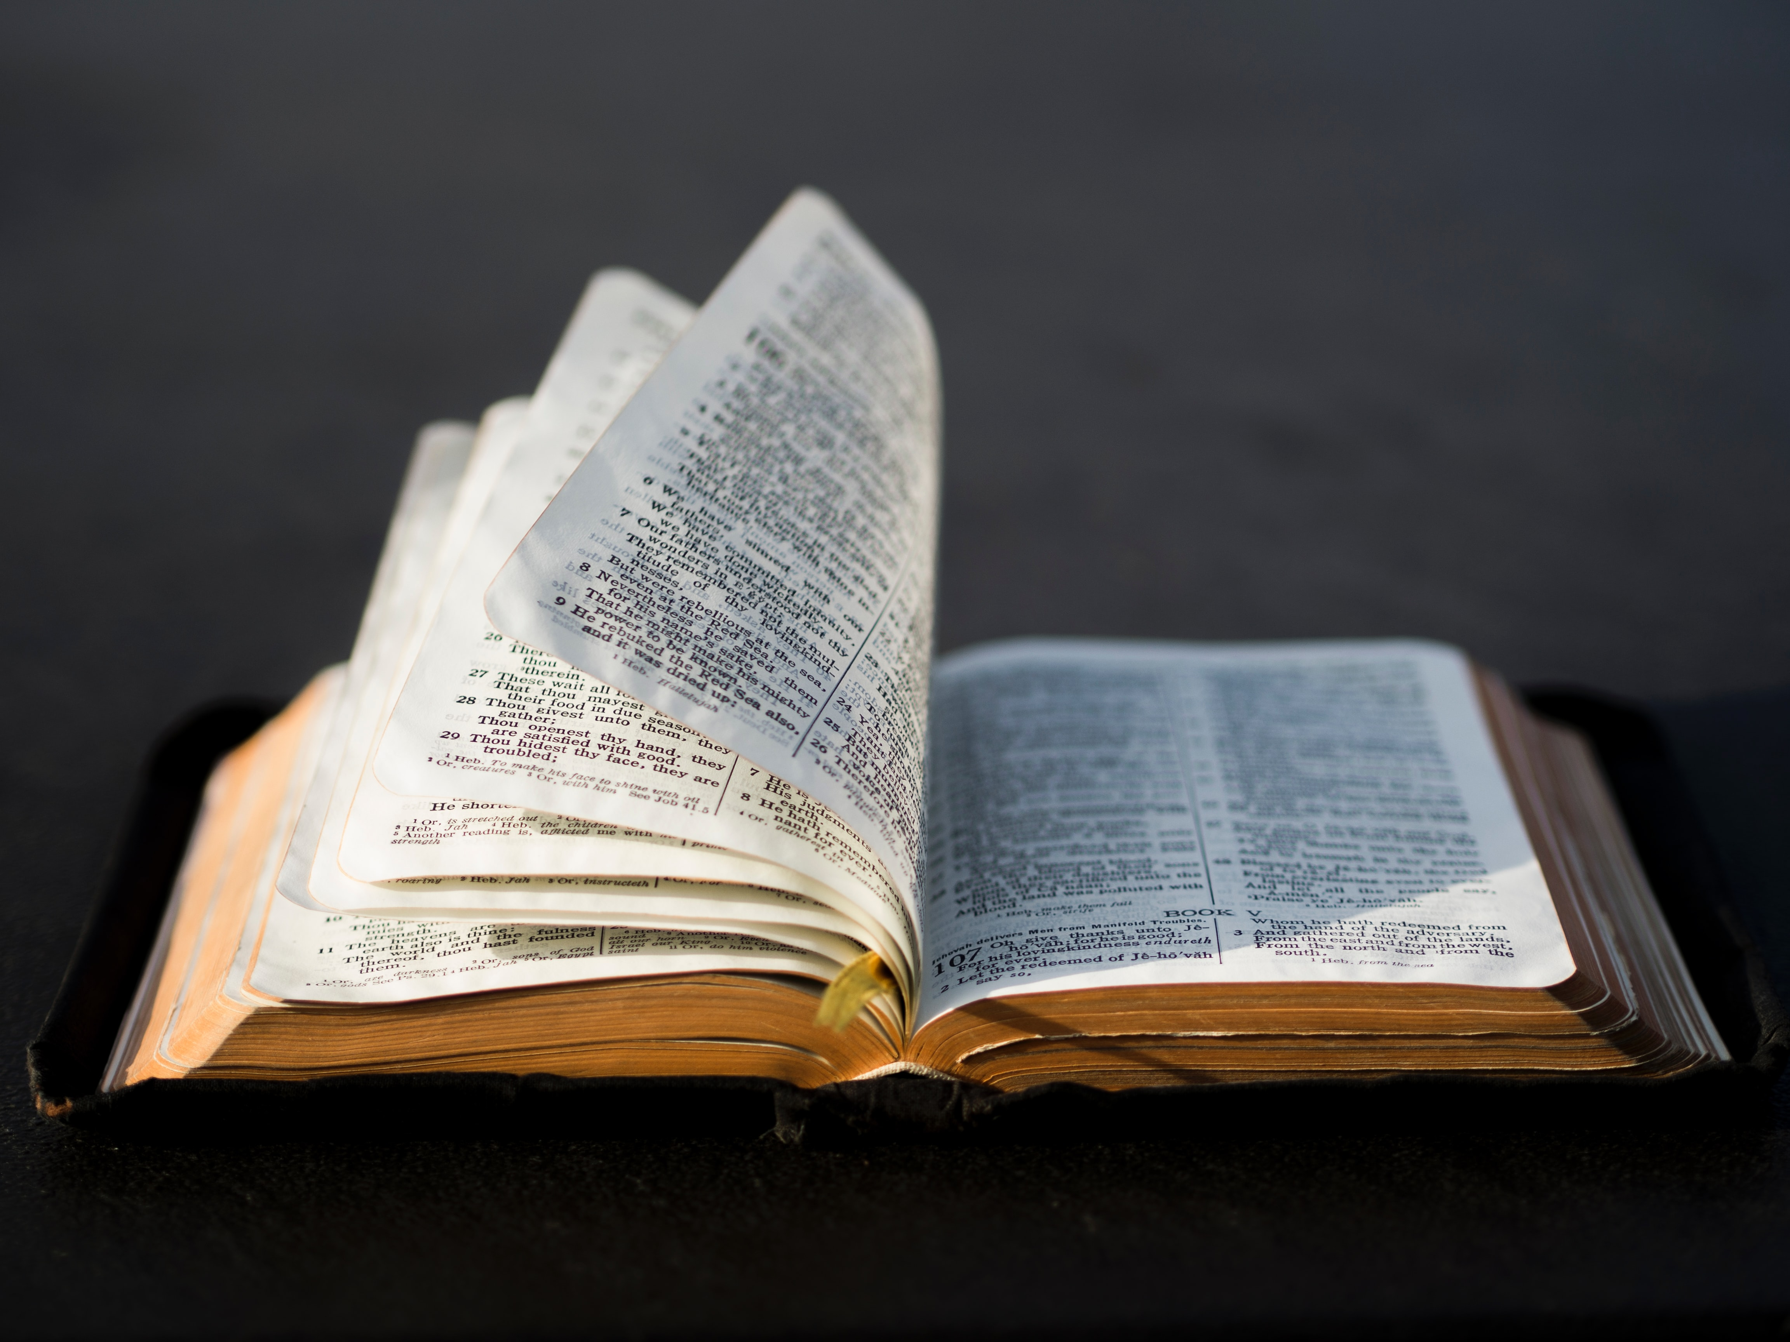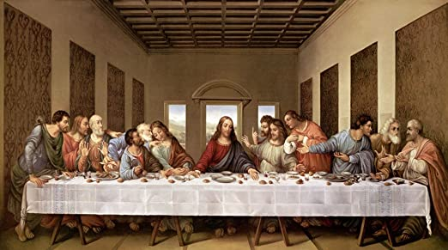

Lord’s Supper

Want to Give through

credit/debit card?

Call Jan Patchett at 619-890-9914

Next Sunday -

February 7, 2021

**Church Services:**

**9:00 AM and 10:45 AM**

CONTACT US:

1150 Broadway, Suite 234

El Cajon, CA 92021

If you have questions:

Call Raylene at 619-733-0748

Email: [raylene7777@icloud.com](mailto:raylene7777@icloud.com)

[www.elcaminograce.org](http://www.elcaminograce.org)

[www.elcaminograce.org](http://www.elcaminograce.org)

**JESUS**

&

**Modern**

**MORALITY**